SIMATS ENGINEERING
ASSESSMENT TOOL 3: Game Based Learning Assessment
COURSE NAME: ARTIFICIAL INTELLIGENCE AND EXPERT SYSTEMS
COURSE OUTCOME COVERED
COURSE CODE: MLA01
CO1: Apply search algorithms and heuristic techniques to solve state-space search and optimization problems. (BTL 3)
Assessment Tool Weightage: 40 %
Total Marks: 50 Time: 60 Mins No. of Questions: 5
Annexure A
Game Based Learning Assessment
Code of Conduct:
I K Sathwik Kumar (192425051) (Name / Reg No) certify that this submission is my original work and that I have adhered to the guidelines specified for this assessment. I understand that any violation of academic integrity rules will result in disciplinary action.
Signature of the student: K Sathwik Kumar
Criterion | Weightage | Marks Obtained
Understanding of the Problem / Game Objective | 10%
Application of AI Search /  Problem-Solving Technique | 15%
Successful Completion of the Game / Puzzle | 20%
Efficiency of Solution / Optimal Moves | 10%
Documentation / Evidence of  Completion | 15%
Understanding of the Problem / Game Objective | 15%
Originality and Critical Thinking | 15%
Total | 100%

Signature of the Faculty Total Marks Awarded
Answer All the Questions
Q. No. | Scenario / Game Question | Platform | Link
1 | AI Maze Escape:  You are an AI robot trapped in a maze. Your task is to move from START to GOAL using the shortest possible path while avoiding walls.  Challenge: Find the shortest path and record the number of steps taken. | Scratch | https://scratch.mit.edu
2 | N-Queens Challenge:  You are an AI chess strategist. Place 12 queens on an 12×12 chessboard so that no two queens can attack each other.  Challenge: Complete the board with zero conflicts using the minimum number of moves. | Online N-Queens Game | https://www.n-que
 |  |  | ens.com
3 | Water Jug Puzzle:  You are an AI agent solving a water jug problem. You have two jugs with capacities of 11 litres and 9 litres. Neither jug has measurement markings.  Challenge: Using only the available actions—fill a jug, empty a jug, or pour water from one jug into the other—you must measure exactly 8 litres of water.  Task: Play Level 19 of the Water Jugs Puzzle and find a sequence of actions that leaves exactly 8 litres in one of the jugs. Try to solve the puzzle using the minimum number of moves. | Tic-Tac-Toe | https://playtictact oe.org
4 | Connect Four AI Challenge:  You are playing against an AI opponent. Your goal is to connect four of your pieces in a row before the AI does.  Challenge: Plan your moves carefully and defeat the AI opponent. | Connect Four | https://www.math sisfun.com/games /connect4.html

S.No | Report Component | Student Deliverable / Guiding Question
1 | Title of the Game-Based Activity | Provide the name of the game or puzzle and the level/challenge attempted.
2 | Game Platform / Link | Mention the platform or website used and provide the corresponding game link.
3 | Objective of the Activity | Explain the objective of the game and the target that needs to be achieved.
4 | Problem Statement | Describe the problem or challenge given in the game. What is the student required to solve?
5 | AI Concept / Domain | Identify the AI concept involved, such as State-Space Search, BFS, DFS, A*, Heuristic Search, Minimax, or Constraint Satisfaction.
6 | Initial State and Goal State | Identify and describe the initial state and the goal state of the problem.
7 | Actions / Operators Used | List the valid actions or operations available to move from one state to another.
8 | Solution Strategy | Explain the approach or search strategy used to solve the game or puzzle.
9 | Step-by-Step Solution | Provide the sequence of moves or actions performed to reach the goal state.
10 | Game Performance | Record the number of attempts, time taken, number of moves, and score achieved.
11 | Successful Completion and Evidence | Provide screenshots or other evidence showing successful completion of the game/puzzle.
12 | Efficiency and Optimality | Analyse whether the solution was optimal or efficient. Can the puzzle be solved using fewer moves or less time?
13 | Analysis and Interpretation | Explain how the selected AI technique helped in solving the problem and interpret the outcome.
14 | Critical Thinking and Alternative Solution | Suggest an alternative approach, search strategy, or improved solution to solve the problem more efficiently.
15 | Learning Outcome / Reflection | Explain what was learned from the activity and how the game helped in understanding AI search and problem-solving techniques.
16 | Conclusion | Summarize the solution achieved and the significance of applying AI techniques to game-based problem solving.
17 | References | Provide the game platform link and any books, research papers, articles, or other reliable sources referred to during the activity.

Structure of the Report – Game-Based Learning

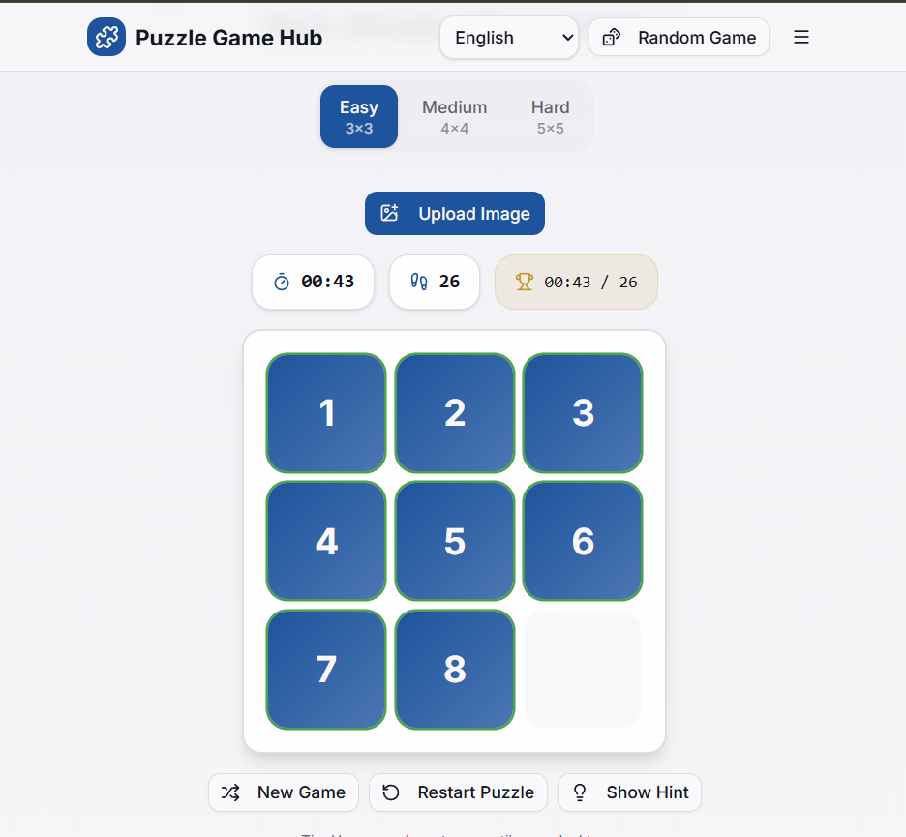

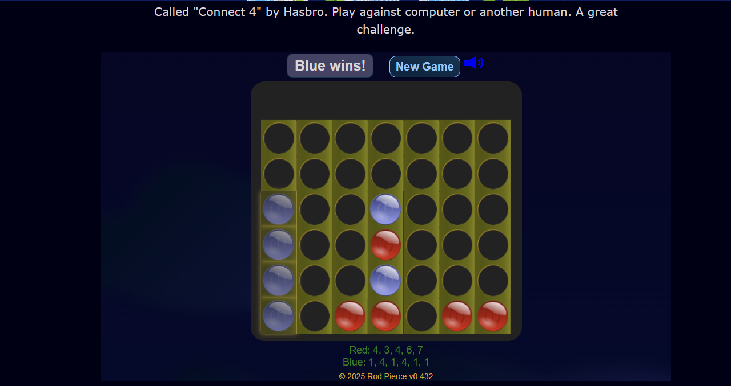
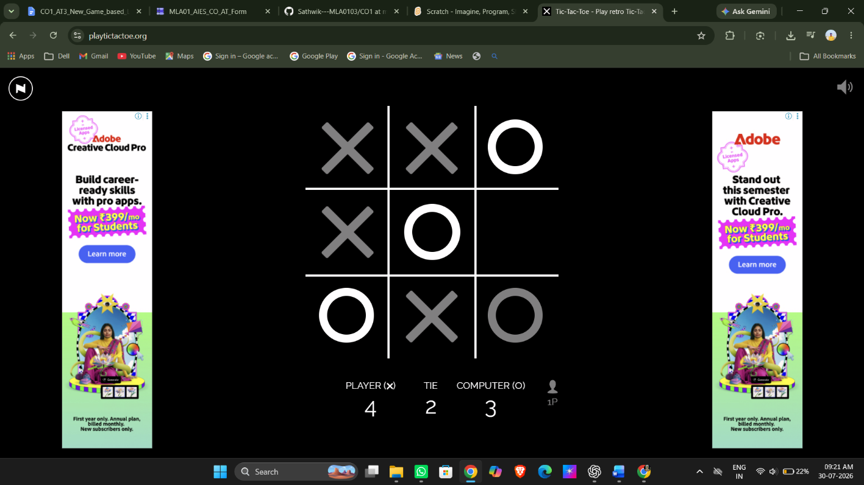

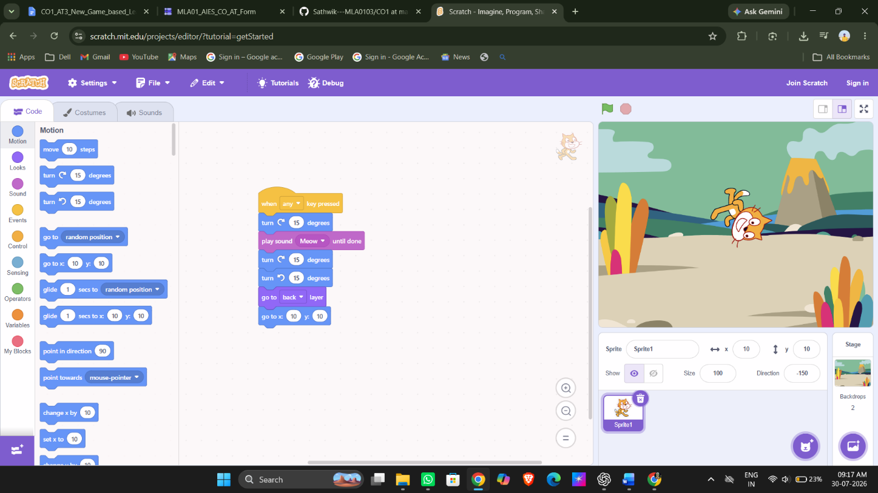

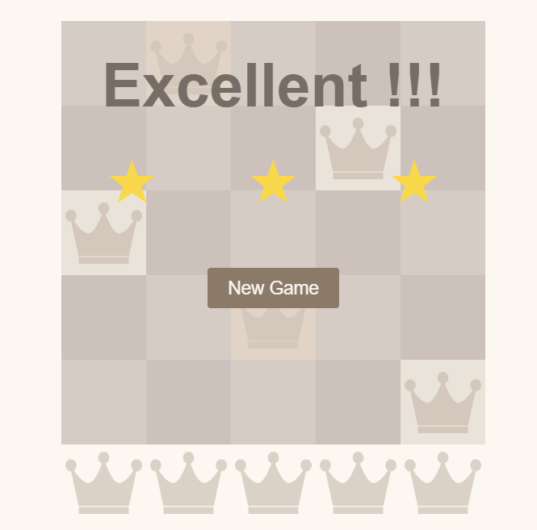

Evaluation Rubrics
Criteria | Percentage (%) | Excellent | Good |  | Satisfactory eds Improvem
Understanding of the Problem / Game Objective |  | 10% Clearly understands the problem and game  objective | Understands the objective with minor  errors | Partially  understands the problem | Does not  understand the objective
Application of AI Search / Problem-Solving  Technique |  | 15% Correctly applies the appropriate AI search or problem-solvi ng technique | Applies the technique  with minor  errors | Shows  limited  application of the technique | Unable to  apply the  appropriate technique
Successful Completion of the Game / Puzzle |  | 20% Successfully solves/compl etes the  game  independentl y | Completes  the game  with minimal assistance | Partially  completes  the challenge | Unable to  complete the challenge
Efficiency of Solution / Optimal Moves |  | 10% Solves using optimal or  highly  efficient  moves | Uses a  reasonably efficient  sequence of moves | Uses several unnecessary moves | Solution is  highly  inefficient or incomplete
Documentation / Evidence of Completion |  | 15% Provides clear steps, score,  screenshots, and evidence of completion | Provides  most  required  evidence | Provides  incomplete steps or  evidence | Provides no proper  documentatio n or evidence
Analysis and Interpretation of the Solution |  | 15% Clearly analyses the solution and explains the AI technique and outcome | Provides a  good  analysis with minor gaps | Provides  limited  analysis or  explanation | Unable to  analyse or  interpret the solution
Originality and Critical Thinking |  | 15% Demonstrate s excellent  independent thinking and explores an  effective or alternative  solution | Demonstrate s good  independent thinking | Shows  limited critical thinking | Shows little or no  independent thinking

